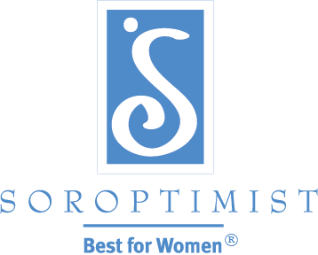

Soroptimist International of the Americas

Soroptimist International of the Americas is a global volunteer organization that economically empowers women and girls by providing access to education, the single most effective anti-poverty intervention.

Live Your Dream Award

- An education and training award given to assist women who provide the primary source of financial support for their families by helping them with the resources they need to improve their education, skills and employment prospects.

- Recipients may use the cash award to offset costs associated with their efforts to attain higher education.

  - Tuition
  - Books
  - Childcare
  - Transportation
Additional Information for the Live Your Dream Award – www.soroptimist.org
Our Local Club – Soroptimist International of Davie (www.sidavie.org)
Applications must be submitted to Soroptimist International’s website by November 15, 2018. The effective date of the award for Soroptimist International of Davie is February 1, 2019.
Please contact Sue Greenawalt, fassanel@att.net, for additional information and help with completing your application.

