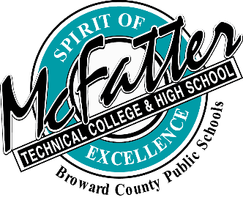

APPEAL CLASSIFICATION PROCESS FOR FLORIDA RESIDENCY IN-STATE TUITION
The Broward County Post-Secondary Technical Colleges’ Institutional appeal process encourages any student to submit a Florida Residency Tuition Classification Appeal form with attached documentation, and sign a Release of Information Form to allow the designated officer or appeal committee permission to review their information. The residency classification appeal must be received within 10 days from the date a student is informed that they are not eligible to pay in-state tuition. The residency appeal officer or committee will render to the applicant, within 30 days, the final residency determination in writing. The applicant will be advised of the reasons for the determination. The Institution’s Appeal Committee or Officer’s decision is final.

