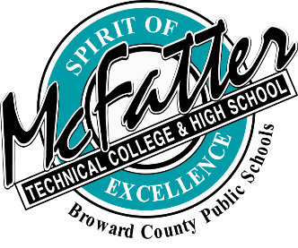
APPEAL CLASSIFICATION PROCEDURES FOR TECHICAL COLLEGES FLORIDA RESIDENCY IN-STATE TUITION

- Broward Counties Post-Secondary Technical Colleges’ Florida Residency Classification form for an In-State Tuition Appeal is completed by the student or applicant, and submitted to the designated officer or committee with the attached documentation to prove the request for a change in Florida Residency status.
- The appeal with documentation must be submitted to the Institution’s Residency Officer or Committee within 10 days of the date the student is informed that they are not eligible for in-state tuition.
- A completed Florida Residency Classification Appeal Form and the documentation showing proof of Florida residency will be reviewed within 30 days of the date listed on the student’s appeal form.
- The student may be required to attend the appeal meeting.
- The student must sign a Release of Information Form before their information is presented for review.
- The institution’s Appeal Committee will be comprised of the following:
  - Administrator
  - Director of Office of Admissions
  - Counselor
- A designated Residency Officer is appointed by the Institution’s Director.
- Other expert resources may include: An INS Coordinator, Financial Aid Director, and Residency Staff of the Florida Department of Education.
- Written notification of the approval or disapproval with reasons will be mailed to the applicant within 10 days.
- All residency tuition decisions are final.

Technical Colleges, 5/10/2016

