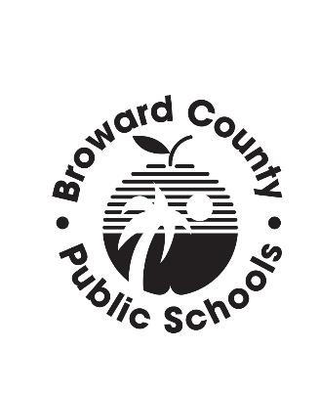
APPEAL OF FLORIDA RESIDENCY

CLASSIFICATION FOR IN-STATE TUITION

Name:_____________________________ Program: __________________________________
Address: _____________________________________________________________________

Telephone # Where You May Be Reached: __________________________________________
I am considered an Independent or Dependent Student in accordance with the Federal Pell Grant Regulations? Independent _____________ Dependent ______________

I request a re-classification of my residency for the following reasons:

Describe what documentation you have provided to prove Florida Residency for the past 12 months prior to the first day of enrollment in your program.

Student Signature: ________________________________ Date: _______________________
5/10/2016

